PCB Review.

Issue No. 1

PCB has DRC Errors and Warnings which needs to removed. See the attached image.

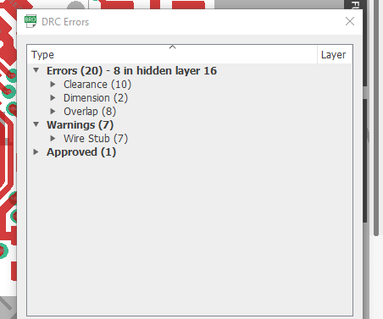

Issue No. 2

Few of the Routes are not good and can be deal in better way. See the attached image.
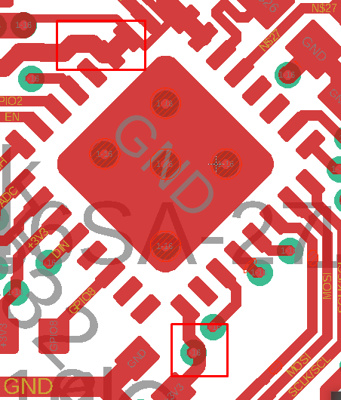

Issue No. 3
Via shielding must be done along the complete area of Antenna and it’s net instead of some limited area.

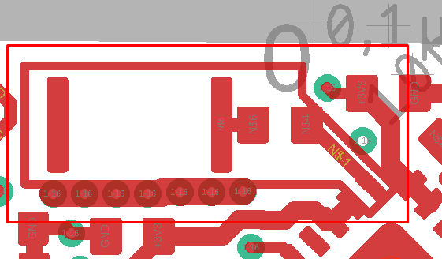

Issue No. 4
Typical layout guidelines for U1 (MCP73831) not followed properly as per datasheet.See attached image.

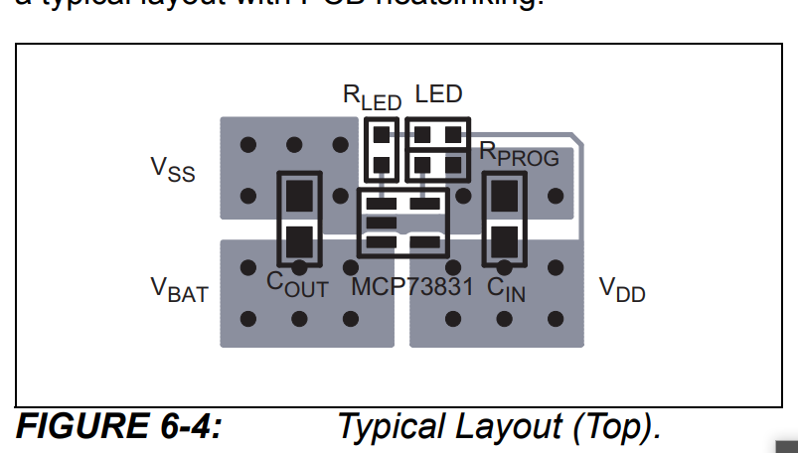

Issue No. 4
51Ohm Resistor is missing in design which needs to be connected on Data pin of Microphone (MIC1) for optimum SNR.

Suggestion No. 1

Antenna placement can be more accurate by placing it at one of the corners of PCB instead of placing it in between other components.

Suggestion No. 2

1x Capacitor of 4.7uF and 1x Resistor of 1M is missing in design which is recommended to be connected with Shield pin of USB C connector.

